**Code Operation Guide**

1. **Running environment**

In the root of the code, running “pip install -r requirements.txt” will install the environment. Python version is 3.7.

Code directory of reading data sets

1. **Overall**

Checkpoint of training

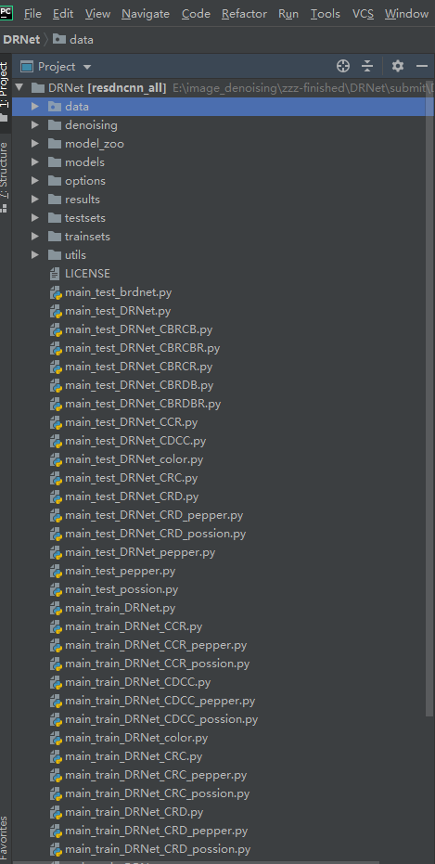

Train and test files

Tool files

Datasets

The results of the tests

Configuration files

Model file based on pytorch

Pre-trained model

1. **Training**

We use DRNet as an example of training and testing, and others are similar.

The configuration file is in the “options” directory

**3.1 Gaussian noise**

The dateset can be obtained by referring to the the paper or “Readme.md” file.

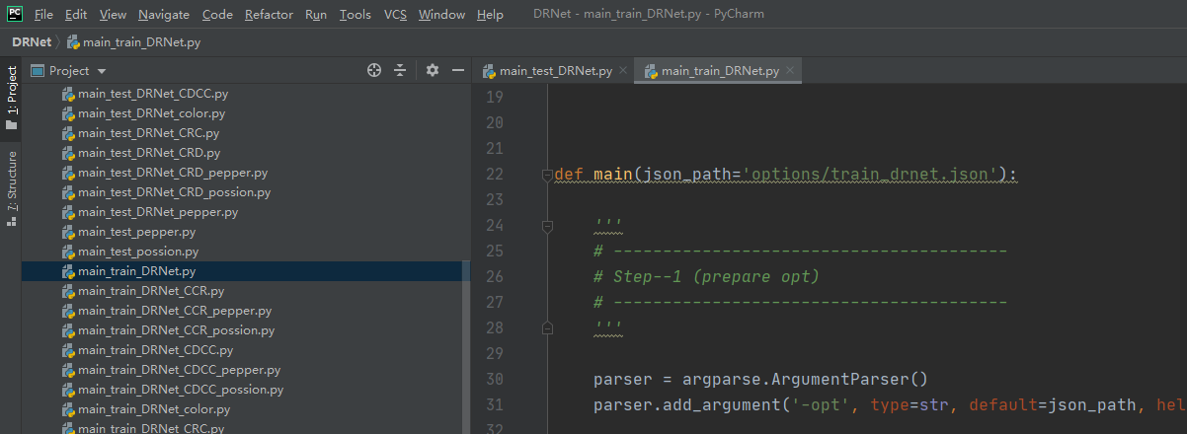

For color images

For gray images

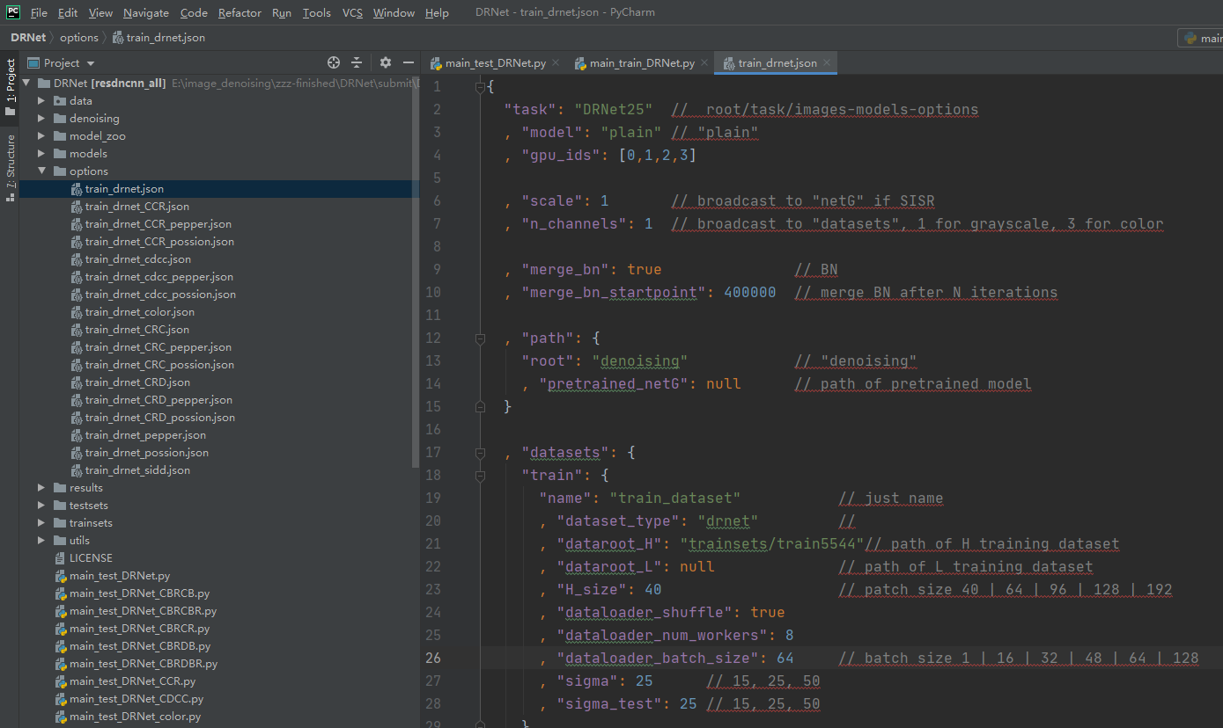

The parameters are accompanied by notes

Running :

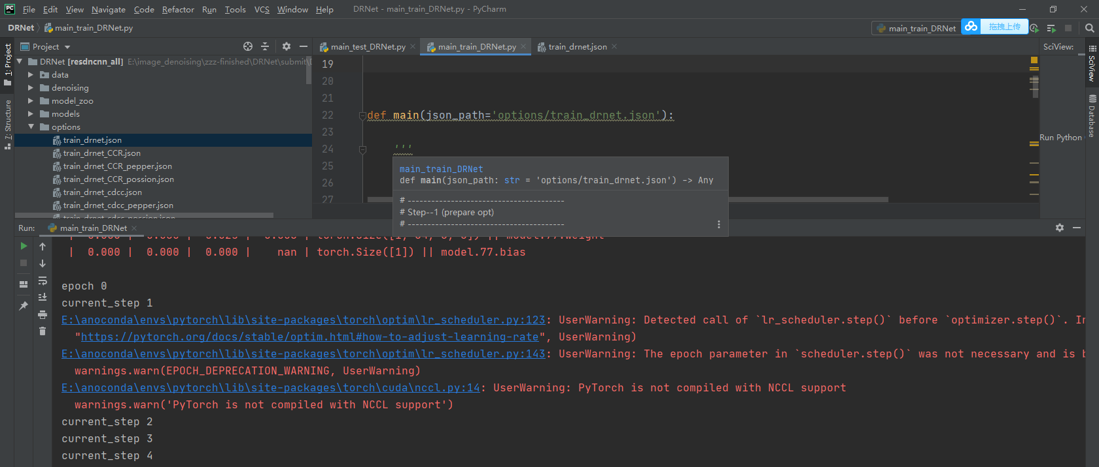

**3.2 Possion noise and salt & pepper noise**



It needs to be clarified that in this paper we do Poisson and salt and pepper noise tests on four better resblocks. So these noises are not tested on DRNet_CBRCB, etc.

**3.3 Real noise**

For real noise dataset, we use sRGB images from SIDD(http://130.63.97.225/sidd/dataset.php). Please download the dataset and put the “Data” directory in “trainsets”. Besides, the validation data should be put in testsets

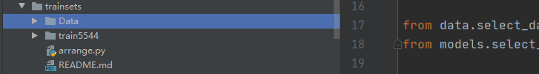

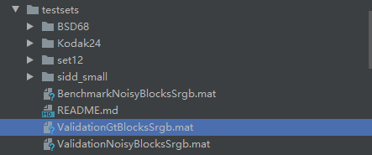

Running:

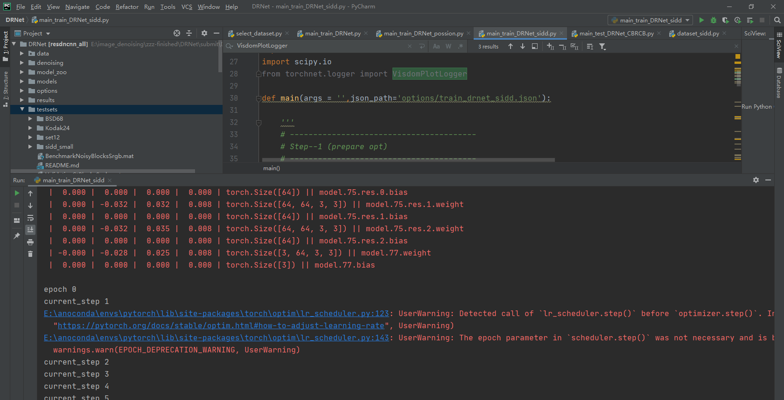

1. **Test**

**We provide test code and pre-trained model in the code.**

Change the noise level here, 15, 25, 50

**4.1 Gaussian noise**

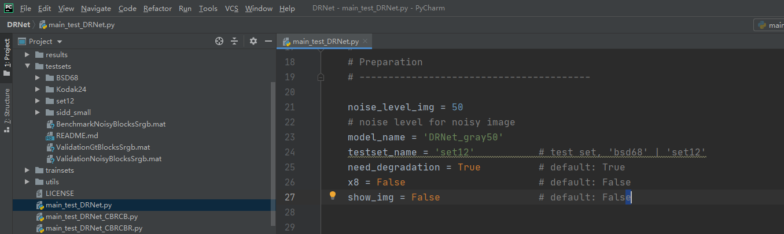

Testset

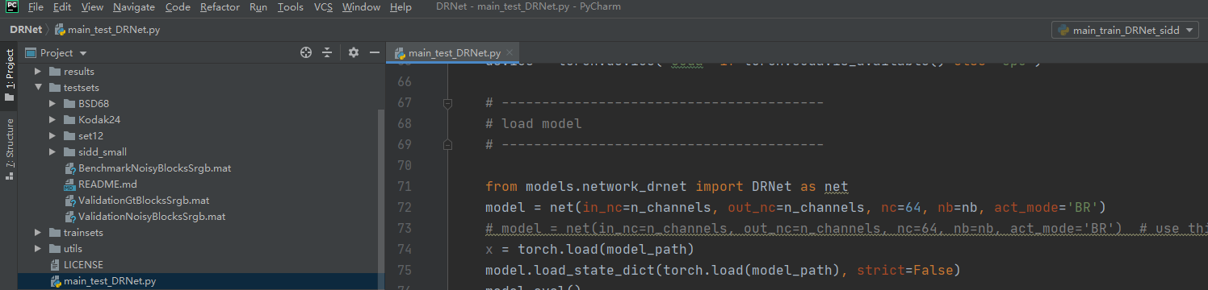

Changing the test model or you can run the corresponding test file directly

Running:

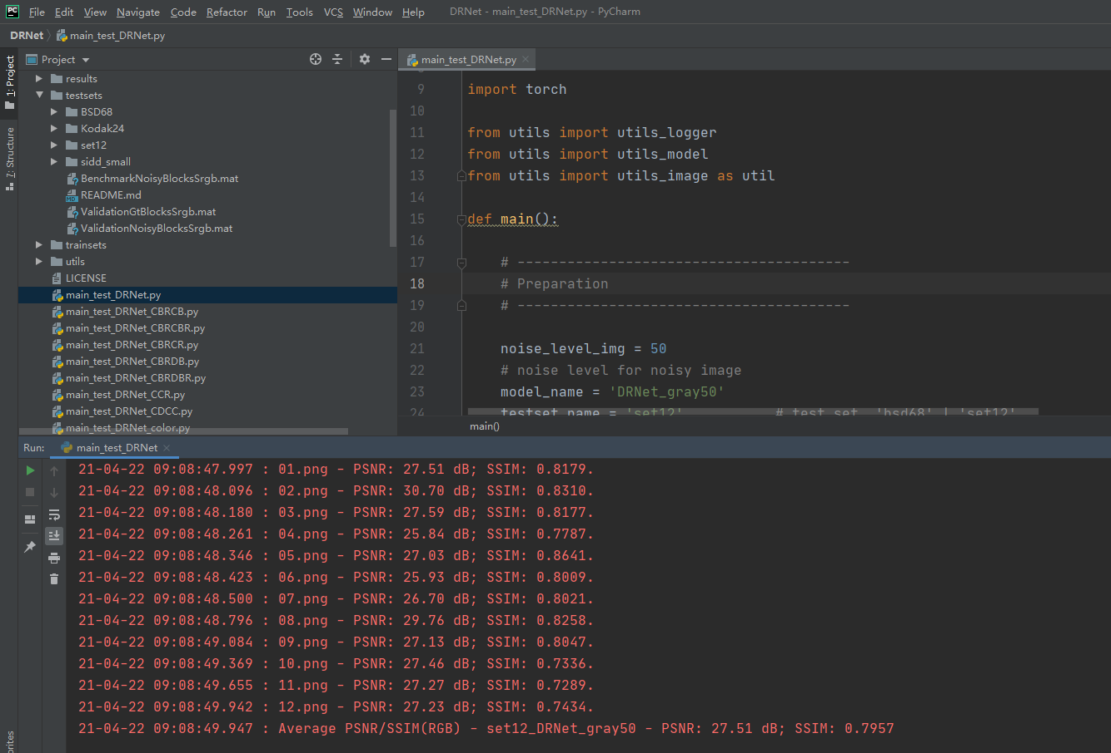

The output images:

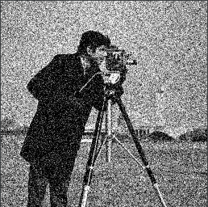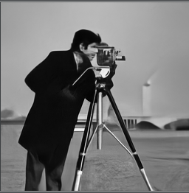

4.2 **Possion noise and salt & pepper noise**

The experiments of possion noise and salt & pepper noise are used as a contrast in ablation experiments. So we didn't compare DRNet with other networks dealing with this kind of noise specially.

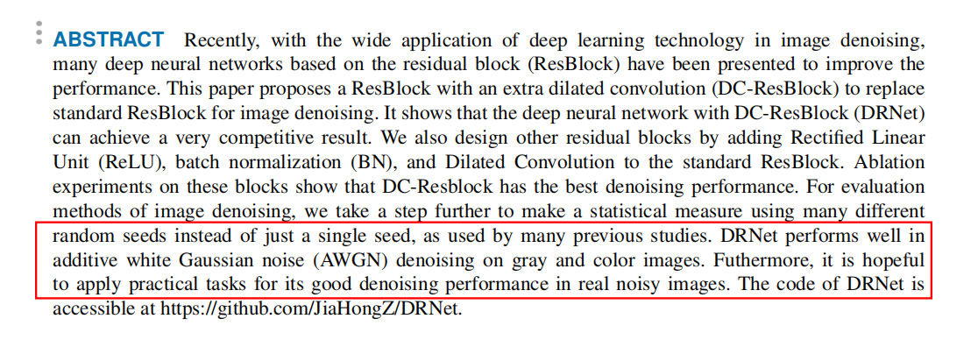

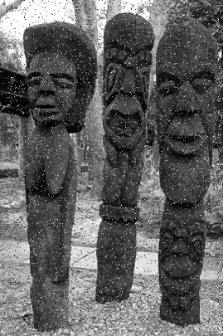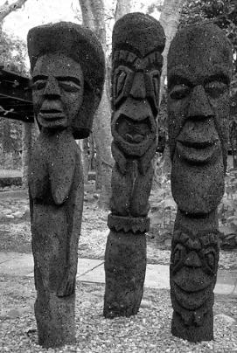

**4.3 Real noise**

We use the official test method provided by SIDD data set for real noise testing. Run the “Submit.py” to generate a file named “SubmitSrgb.mat”, then submit it to http://130.63.97.225/sidd/benchmark_submit.php

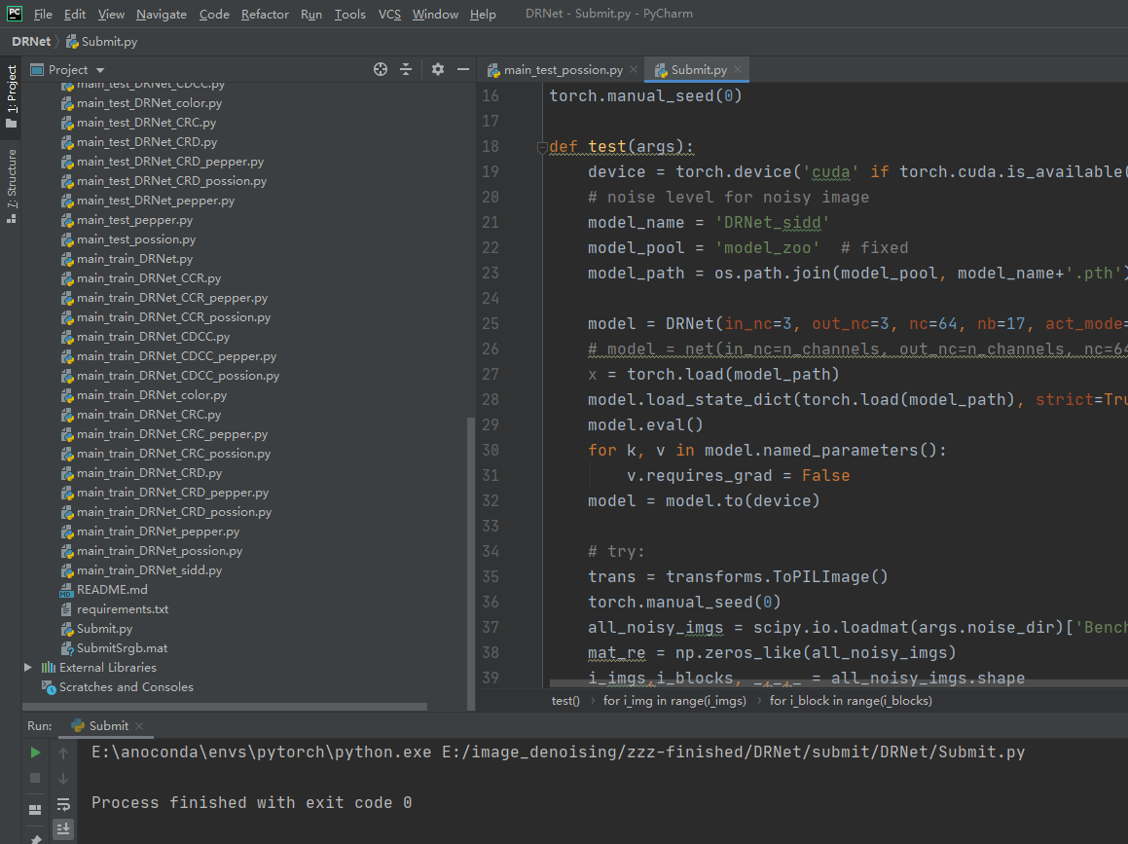

The results obtained by the mailbox are as follows:

PSNR_Srgb,SSIM_Srgb,TimeSrgb(s)

36.33,0.931,-1

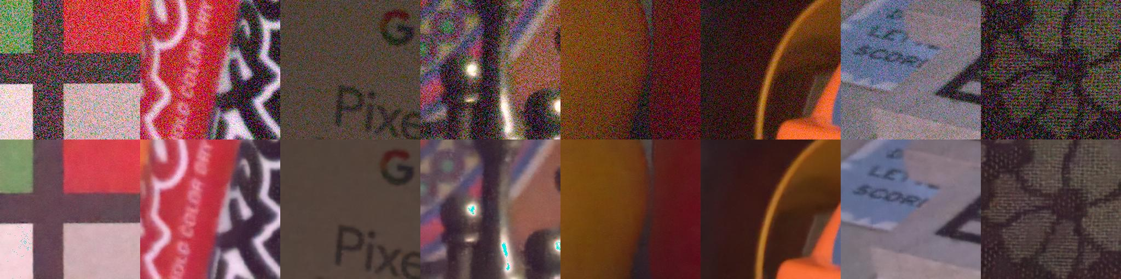

If you want to test other real noise images, you can modify the main_test_DRNet.py.